* **B1: Download STS**

<https://spring.io/tools>

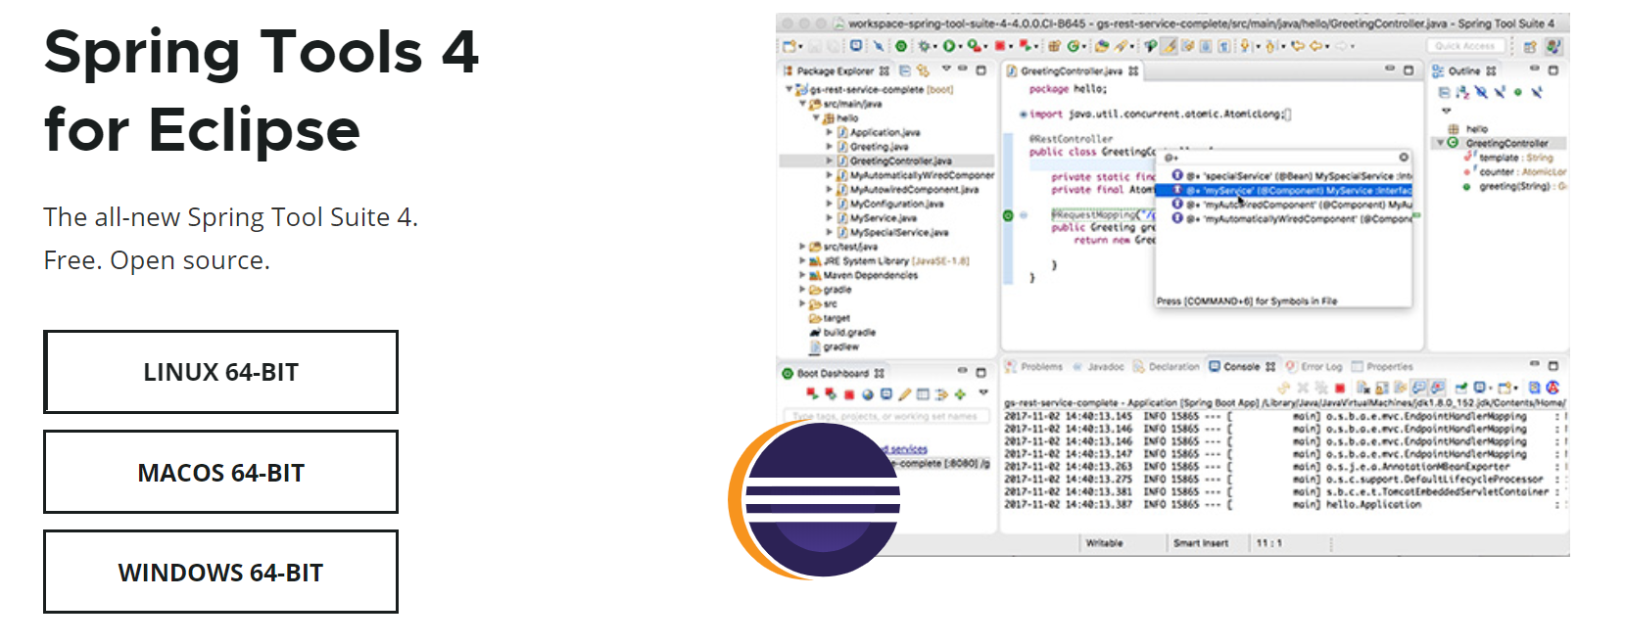

* **B2: Extract file**

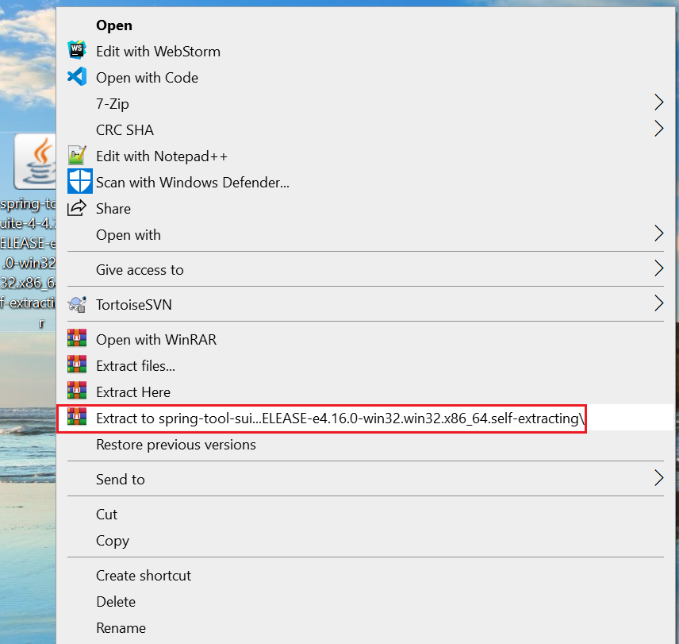 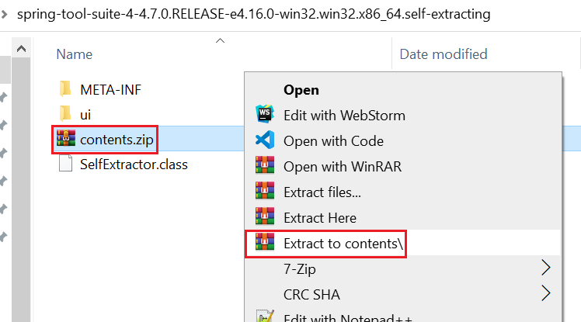

*Nên cho vào ổ C:\Program Files cho đồng bộ*

* **B3: Run STS**

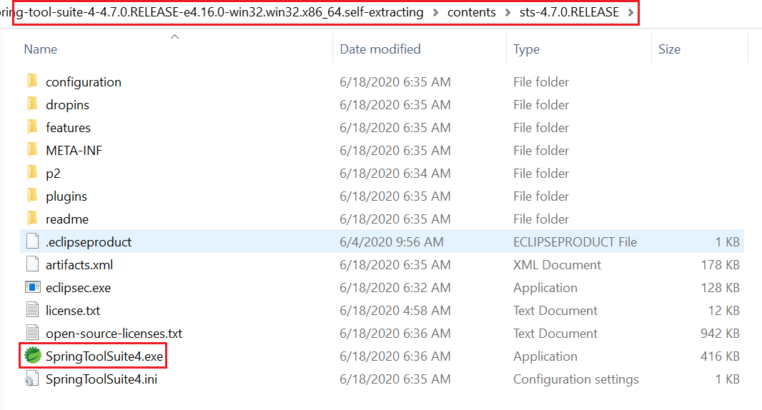



* **Reference**

<https://www.youtube.com/watch?v=MrgIY7GslXQ>